EX-1: Loading and Inspecting a Real-World Dataset.
AIM,ALGORITHM,PROCEDURE,PROGRAM Eludhanum
Input dataset , output print edukanum
Result oru page la keela eludhanum

Aim:
To perform initial Exploratory Data Analysis (EDA) on the Titanic Passenger Dataset by loading it into a Pandas DataFrame and examining its structure, dimensions, and statistical summary using Pandas functions.

Algorithm
- Start the program.
- Import the Pandas library, which is used for data manipulation and analysis.
- Load the Titanic Passenger Dataset into a Pandas DataFrame using the read_csv() function.
- Display the first five records of the dataset using the .head() method to get an overview of the data.
- Display the dataset information using the .info() method to view the column names, data types, and non-null values.
- Display the dimensions of the dataset using the .shape attribute to find the number of rows and columns.
- Generate the statistical summary of the numerical columns using the .describe() method.
- Analyze the output to understand the structure and characteristics of the Titanic Passenger Dataset.
- Stop the program.

Procedure
- Download the Titanic Passenger Dataset from Kaggle in CSV format.
- Open the downloaded dataset and verify the records and column names.
- Save the dataset in CSV format with an appropriate file name (e.g., Titanic.csv).
- Open Jupyter Notebook, Google Colab, or any Python IDE.
- Import the Pandas library using the import pandas as pd statement.
- Load the Titanic dataset into a Pandas DataFrame using the pd.read_csv() function.
- Display the first five records using the .head() method.
- Display the dataset information using the .info() method.
- Display the dataset dimensions using the .shape attribute.
- Generate the statistical summary using the .describe() method.
- Observe and analyze the output obtained from the dataset.

Python Program

Program: Load and Explore the Titanic Passenger Dataset
# Import the Pandas library
import pandas as pd
# Load the dataset
df = pd.read_csv("input data set.csv")
# Display the first five records
print("First Five Records")
print(df.head())
# Display dataset information
print("\nDataset Information")
df.info()
# Display the dimensions of the dataset
print("\nDataset Shape")
print(df.shape)
# Display the statistical summary
print("\nStatistical Summary")
print(df.describe())

Input Dataset
Input data set.csv
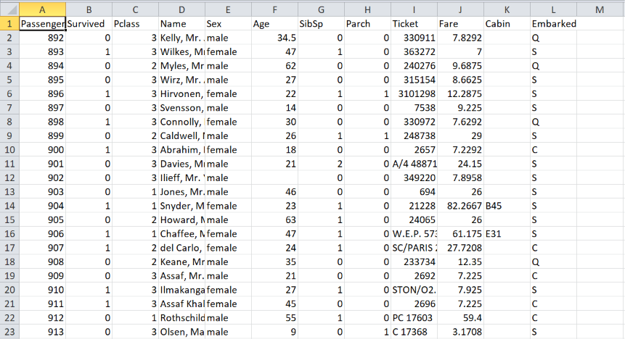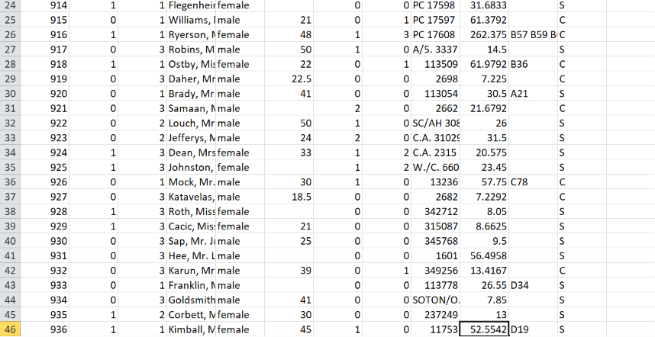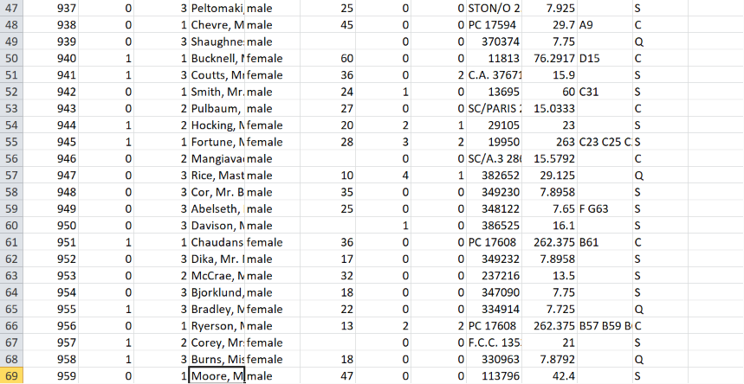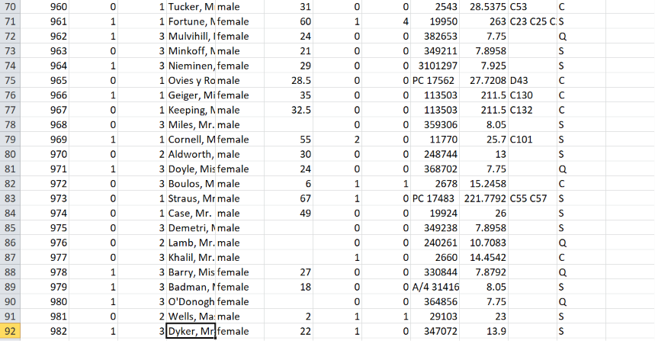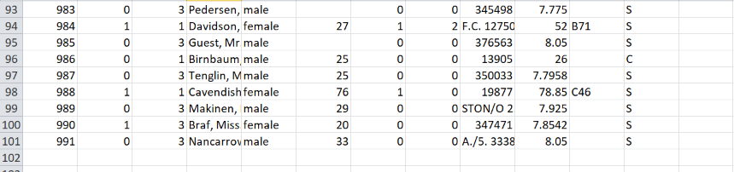

Output

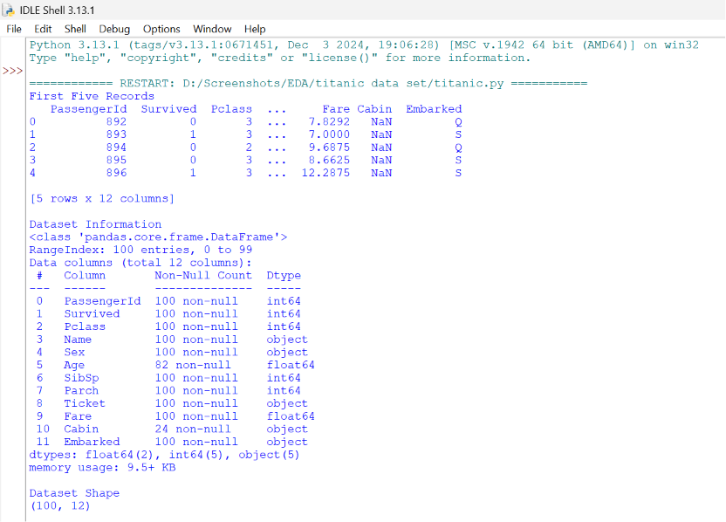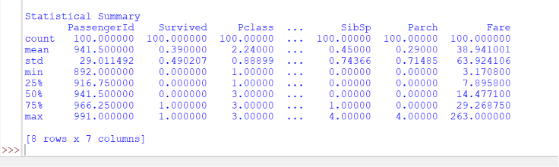

Result
Thus, the Titanic Passenger Dataset was successfully loaded into a Pandas DataFrame. The dataset structure was examined using the .head(), .info(), .shape, and .describe() methods, and the required Exploratory Data Analysis (EDA) operations were performed successfully.

